**Super Market Sales Report**

The Ms Sql setup

I created a database name supermarket

And imported a given csv file ‘supermarket_sales’

I modified data types and decreased the round up values 2 decimal places for this

I created a view with name of ‘vsupermarket_sales’ with updating data

**1.Total Sales:**

Query:

select round (sum (Total_sales),0) as 'Total_sales'

From vsupermarket_sales

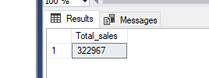Result:

**2. Sales distribution by branch:**

Query:

SELECT Branch, round (sum (Total_sales),0) as Total_sales

from vsupermarket_sales

group by Branch

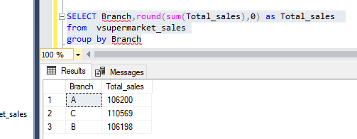 Result:

**3.Sales distribution by city:**

Query:

SELECT City, round (sum (Total_sales),0) as Total_sales

from vsupermarket_sales

group by City

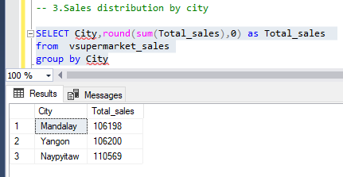 Result:

**4.Total sales vs Customer type:**

Query:

SELECT Customer_type, round (sum (Total_sales),0) as Total_sales

from vsupermarket_sales

group by Customer_type

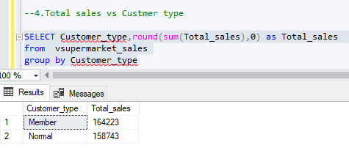 Result:

**5.Sales distribution by product line:**

Query:

SELECT Product_line, round (sum (Total_sales),0) as Total_sales

from vsupermarket_sales

group by Product_line

Result:

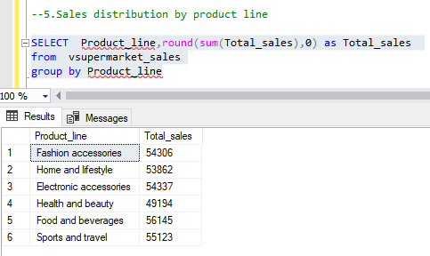

**6.Percentage of sales distribution by Gender:**

Query:

SELECT Gender,

SUM(Total_sales) AS Total_Sales,

Round((SUM(Total_sales) / (SELECT SUM(Total_sales)

FROM vsupermarket_sales)) * 100,0) AS Sales_Percentage

FROM vsupermarket_sales

GROUP BY Gender;

Result:

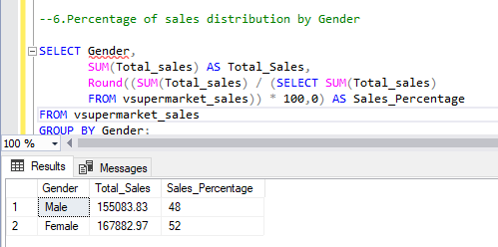

**7.Sales distribution by month:**

Query:

SELECT

FORMAT (Date1, 'MMMM') AS Month,

Round (SUM(Total_sales),0) AS Total_Sales

FROM vsupermarket_sales

GROUP BY FORMAT (Date1, 'MMMM'), FORMAT (Date1, 'MM')

ORDER BY FORMAT (Date1, 'MM');

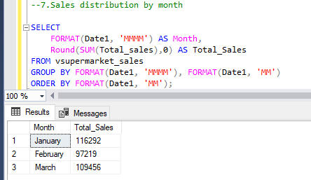 Result:

**8.Percentage of payment distribution by Payment method:**

Methods we have

1.Cash

2.Credit card

3.Ewallet

Query:

SELECT Payment,

SUM(Total_sales) AS Total_Sales,

Round((SUM(Total_sales) / (SELECT SUM(Total_sales)

FROM vsupermarket_sales)) * 100,0) AS Sales_Percentage

FROM vsupermarket_sales

GROUP BY Payment;

Result:

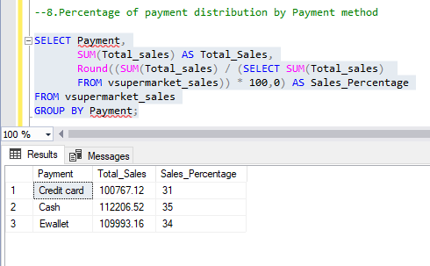

**9.Ratings vs Total sales:**

Query:

SELECT Rating, round (sum (Total_sales),0) as Total_sales

from vsupermarket_sales

group by Rating

order by Rating

Result:

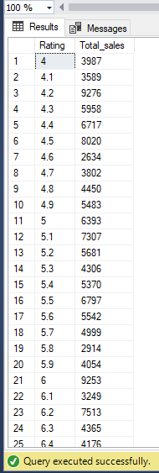

**Conclusions:**

1.the sale in the branch ‘A’ & ‘B’ little less when compared to the branch ‘c’

2.in products which are related to food and beverages have high sales.

3.in payment method cash have little high priority